COMP1516

Session #6 Lab

**In-Class Lab**

1. Create a Python Project with the name Lab6
2. Create a Python file called lab6.py
3. In file lab6.py Create function main in the format:

def main():

pass

if __name__ = “__main__”:

main()

Create the following functions:

* Function weight_converter(), the function converts weight in kilos to weight in pounds, the function displays a table of the weight from 30 kilos to 100 kilos in increments of 10 and displays the corresponding weight in pound up to two digits after the decimal point for each value.

**Hint: 1 Kg = 2.20 pounds.**

Here is an example of the expected output

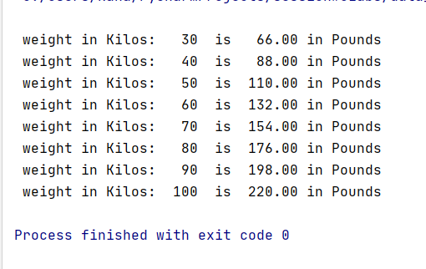

* Function get_ divisible(), the function prompts the user to enter three numbers, first number, second number and divisor.
  + If the first number is less than the second number then the function will display all the numbers between first and second number inclusive that are divisible by the given divisor.
  + If first number was greater than second number then the function will display all the numbers between the fist and the second number that are divisible by the given divisor in a descending order.
  + The divisor cannot be 0. If the divisor was 0 the message “ the divisor cannot be 0” will be displayed and the function will terminate.
* Function get_list_stats(), the function prompts the user to enter positive integers, space to end the input . If the user entered anything other than an integer it will be ignored. If the user entered and integer it will be added to a list.

The function displays the list of integers, the length of the list, number of even numbers, min and max numbers **.Do not use min and max functions**.

Note that 0 is a positive number.

* In the main function call methods weight_ converter, get_divisible and get_list_stats

**Take-Home lab:**

In file lab6.py add the following functions:

* Function calculate_pay(), the function takes two parameters number of employees and hourly rate. The function creates a list of lists. Each inner list consists of the number worked hours and the pay of each employee. The size of the list should be the same as the employees’ number. The function will prompt the user to enter the number of worked hours for each employee, calculates the pay of the employee, creates a list of the number of hours and the pay and adds it to the employee list. The pay is calculated as follows.
  + If number of hours is less than 40, then the pay is the number of hours times the hourly rate.
  + If the number of hours is greater than 40, then the pay is the hourly rate is 1.5 for the hours over 40 hours.

The function displays the number of hours and the pay of each employee in the given format:

If the hourly rate is 10 and the number of employees was 4 the output of the function would be:

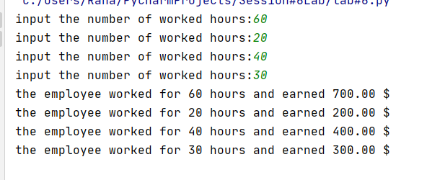

* Function is Prime(), the function takes one parameter which is a positive number and returns True if the number was prime, False otherwise
* Function get_prime_numbers(), the function takes one argument which is a positive integer greater than 2, the function generates a list of integers from 2 to the given number inclusive. The function then iterates through the list and displays all the prime numbers in the list.

Sample output of the function:

If the passed number was 20, the output would be:

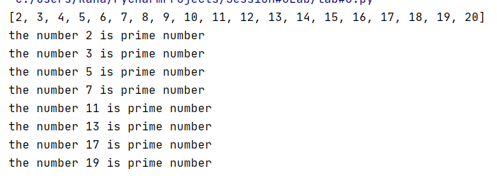

* In function main():
  + Prompt the user to input number of employees and hourly rate, pass the values to function calculate_pay()
  + Prompt the user to enter a positive integer greater than 2 and pass it to the function get_prime_numbers()

Best Practices

* Variable names are descriptive and should be lower_snake_case
* function names should be lower_snake_case

All functions include Doc-String comments

Submission

Submit zipped folder containing project Lab6 to the dropbox before the deadline.